swasnsea metropolitan university
Game Development using TGE
Games Programming and Graphics
Sion Williams p059651
6/6/2008

Develop games using industry standard development tools and software development kits

Running the Game
- To play the game simply double click the Minesweeper.exe file and press start in the main menu GUI.
- In order to disarm bombs simply collide with it and it will be collected.
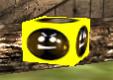

Minesweeper
Minesweeper is a time constrained search and destroy game. The design is very simple; a number of bombs are hidden throughout a level and the player must search the environment in a set time disarming the bombs.
Bombs- these are shape objects that the player interacts with through collision events. They are brought into the mission via Shapes->Bombs in the mission editor. It was important that they were imported as shapes and not static shapes so that they could be interacted with through scripting. The script for the bombs is as follows:
datablock ItemData( SuperBomb )
{
category = "Bombs";
shapeFile = "~/data/shapes/superbomb/superbomb.dts";
};

function ItemData::create( %data )
{
echo( "ItemData::create for SuperBomb called --------------------------" );

%obj = new Item()
{
dataBlock = %data;
rotate = true; // All Super Bomb power-ups will rotate.
static = true; // Super Bombs should stay put so they don't slide away.
};

return %obj;
}

function SuperBomb::onCollision( %this, %obj, %col )
{
//This tests all collisions worked correctly
echo( "SuperBomb::onCollision called ----------------------------------" );

//Checks collision with player
if(%col.getClassName() $= "Player")
{
%client = %col.client;
%obj.delete();
//Gets the number of bombs in the simgroup
%scoreCount = Bombs.getCount();
//Update GUI for the user
commandToClient(%client, 'SetBombCounter', %scoreCount);
if(%scoreCount > 0)
return;
// otherwise display victory screen
commandToClient(%client, 'ShowVictory');
}
}

The script file is very similar to the torquelogo script file given in the tutorial although further scripting has been input to handle the collision event and updating of GUI.
Timer- this is a re-design of the timer used in the pair’s example game. The printing to screen has been kept the same only the code has been adapted to act as a countdown for the bombs rather than a count up. The time the player has to find the bombs is stated in the onMissionDownloadComplete() function, then the gameTimer() function is called. The game timer then calls itself every second.
The game timer was also adapted to incorporate the game losing condition, that is, when the counter reaches 0. This caused problems initially as the commandToClient() needed to know the client it was dealing with. Following some research into the 3D Game Programming All in One (1) book, I found that I could use ClientGroup.getObject(0) to solve the problem.
clinetGame- this is the script file where I stored my functions for setting the remaining bombs, winning window and loosing window. These functions can be called by the client or the server.
function clientCmdSetBombCounter(%score)
{
BombCounter.setText("Bombs Remaining:" SPC %score);
}
function clientCmdShowVictory()
{
MessageBoxOk("You Win!",
"Congratulations you saved the world!!",
"quit();");
}
function clientCmdShowdefeat()
{
MessageBoxOk("You Lose, Bombs went off!",
"Better luck next time",
"quit();");
}

Torque Game Engine
As with any game engine, standard practice is to implement a scripting engine. Whether it’s a proprietary script or a 3rd party script like Lua, this is the preferred method by engine developers for the user to interact with the software. For example the Unreal game engine ships with UnrealScript, World of Warcraft uses Lua. This allows the user to manipulate the game world without changing any of the higher level C/C++ code. Learning new script can be timely but when compared to the amount of time required to learn a programming language like C/C++ and a 3D Graphics library like OpenGL, Torque by comparison has a quick turnover from start to finish.
One of the most beneficial things about torque is the ability to drag and drop environments, the same process in a hard coded environment would take far longer. For a start, each model would need to be converted into a usable form, the model would then need to be positioned then finally textured, and this could take a few hours whereas with Torque the process takes a matter of seconds.
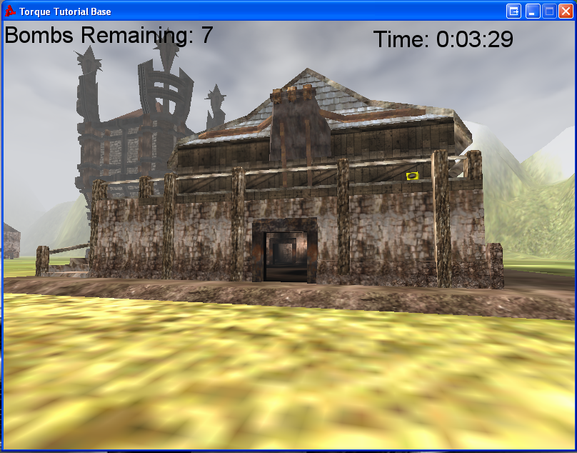

Bibliography
1. Finney, Kenneth. 3D Game Programming All In One. s.l. : Premier Press. 1-59200-136-X.

